[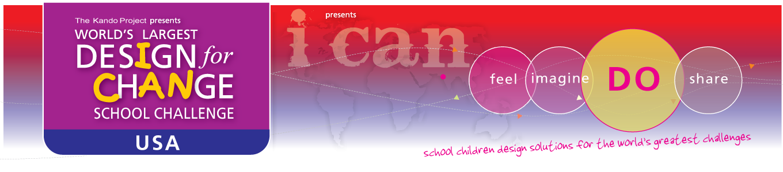](http://www.designforchange.us)

**Welcome dedicated teacher and students!**

Thank you for your interest in the Design for Change School Challenge 2013! We are so happy you have joined teachers and students in over thirty five countries who are saying, “I Can” and creating positive impact around the world.

Design for Change empowers students to develop their creative and problem solving skills while taking authentic and collaborative action to address a challenge in their community. Students are driven to brainstorm, plan, create, and execute their solution in a meaningful and out of the box way. Teachers and mentors act as facilitators and lead students through the Design for Change framework of:

**Feel, Imagine, Do, Share**

To assist you with your project, we have designed a wonderful host of resources including worksheets, tips for teachers, and videos of past projects from around the globe. Our curriculum is designed to be flexible and customizable to suit your needs. You may choose to execute your project in one month or over several months. It is entirely up to you!

* [**FAQs**](http://www.designforchange.us/dfcusa/pages/faq)- Read the FAQs for answers to general questions about Design for Change.
  + <http://www.designforchange.us/faq>
* [**Top 10 Tips**](http://designforchange.us/dfcusa/pages/getstarted)- Read the Top 10 tips for teachers containing best practices and helpful suggestions.
  + <http://www.designforchange.us/getstarted>
* [**Curriculum toolkit-**](http://designforchange.us/dfcusa/pages/documents) The toolkit contains the Design For Change framework as well as documents that will help support and streamline your project.
  + <http://www.designforchange.us/documents>
* [**DFC Videos**](http://www.designforchange.us/dfcusa/pages/3in1)-Watch videos from the US and around the world- a great way to introduce DFC to your students to serve as a point of inspiration for your students
  + <http://www.designforchange.us/videos>
* Email: [info@designforchange.us](mailto:info@designforchange.usa) for more details and answers to specific questions

**Dates to remember:**

* SUBMIT your project by March 30th, 2013
* PRIZES and winners announced on April 30th, 2013

We’d be thrilled if you shared your intention to become a part of the “I Can” movement with your friends and colleagues. A simple forward of this note may inspire more students and teacher/mentors like you.

Thank you again for registering. Let’s show the world what children are capable of and let’s **BE THE CHANGE!**

Sincerely,

The Design for Change USA Team

**News Design for Change:**

* Every year DFC selects the most promising groups of students from around the world to attend the DFC conference in Ahmedabad, India. We're raising funds to send students from the Pearl River Middle School to represent DFC USA.  The students will be recognized for their creativity, hard work, and ability to make change. To learn about how you can donate, please email us at [info@designforchange.us](mailto:info@designforchange.usa)
* DFC is proud to have been recognized by the Rockefeller Foundation with the [Innovation Award](http://www.indiegogo.com/designforchangeUSA).
* DFC USA is excited about our partnership with Teach for America that will empower students in South Dakota to give back to their communities.
* Design for Change USA is a subset of Design for Change International, a global initiative to help children realize their dreams of social change in their schools and communities. We believe that children and teachers are the change makers of tomorrow.

[DFCUSA on Tumblr](http://www.tumblr.com/tagged/dfcusa/) * [DFCUSA on Twitter](https://twitter.com/dfcusa) * [DFC USA on Facebook](http://www.facebook.com/dfcusa?ref=ts)